**Template for Activity with WitBlox Kit**

**Task I:**

**Develop a Robotic Car Assembly and integrate following applications with the car**

1. Edge Avoider Car
2. Obstacle Avoider Car
3. Line Follower Car
4. Remote controlled Car with Wifi Module

**Evaluation Criteria:**

1. Photo of Developed Car
2. Write your understanding from activity

**Performance-15 Marks : Basic Car = 5 marks , Object and Edge Avoider = 5 marks, Line Follower and Car with WiFi Module = 5 marks**

**Submission-10 Marks**

**Team**

|  |  |  |  |
| --- | --- | --- | --- |
| **Sr No** | **Roll No** | **Name** | **Work Done** |
| 1 | 16010423075 | Ritesh Gorule | Blox assembling |
| 2 | 16010423076 | Ritesh Jha | Chassis Assembling |
| 3 | 16010423077 | Ritvik Mohanty | Chassis Assembling |
| 4 | 16010423078 | Riya Amin | Chassis Assembling |
| 5 | 16010423079 | Rohan Jobanputra | Testing |

**Fill your details as per following points**

**Photo of Developed Car**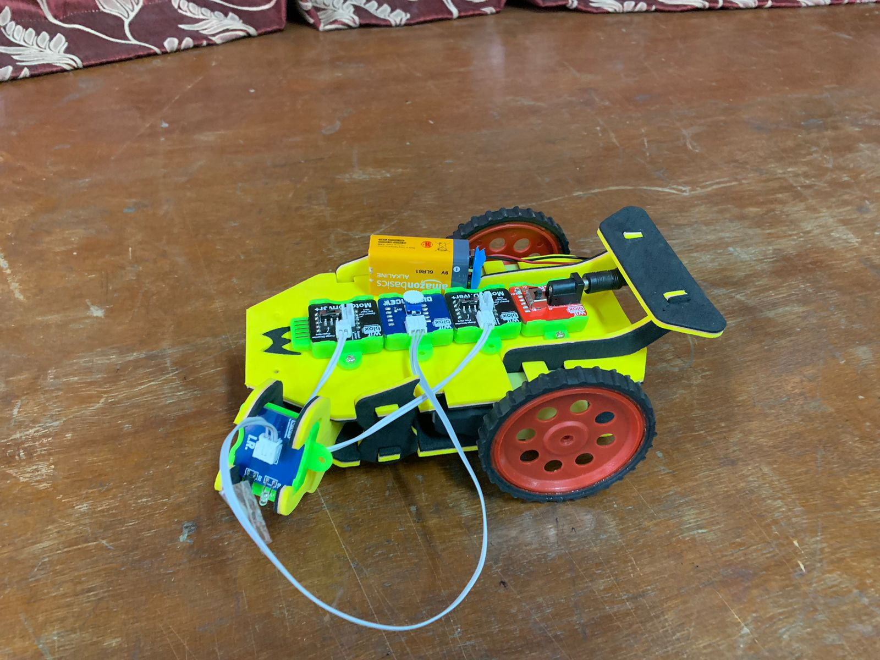

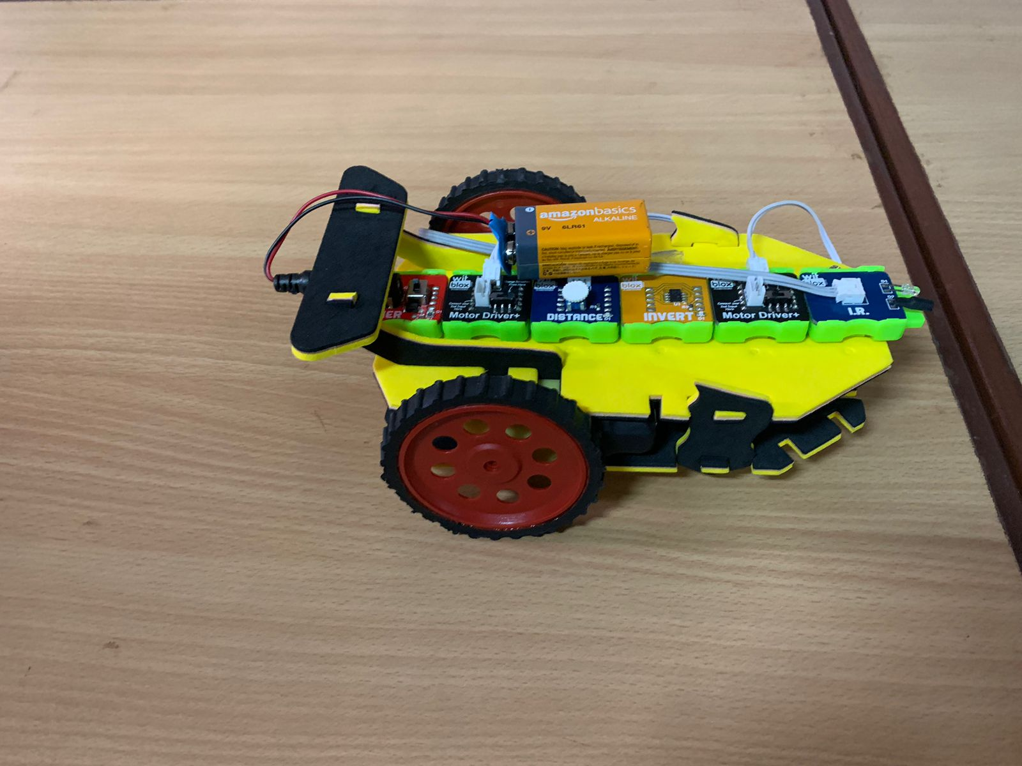

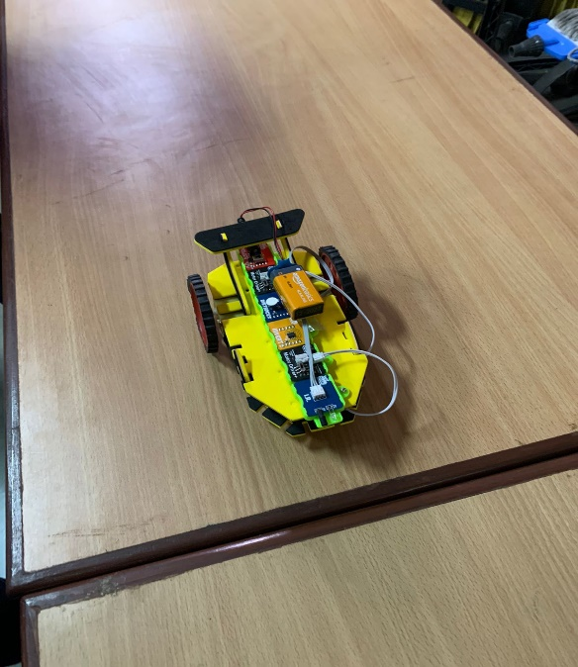

* **Write your understanding from activity**

During the PBL course activity where we built a robotic car, we noticed a few important things. First, putting the car together required both technical skills and teamwork. Each part, like the frame, sensors and Wi-Fi module, had a specific job in making the car work.

Adding sensors to the car for different modes, like Edge Avoider, Obstacle Avoider and Line Follower, showed how versatile the robotic car could be. It was cool to see how the sensors changed how the car behaved, making it respond to different things around it. This showed us how sensors are practical for making smart and adaptable systems.

* **Video of Actual implementation**



* **Observations , reflection on activity**

Reflecting on the PBL course activity, it became evident that the hands-on experience of building a robotic car provided a holistic understanding of the principles of robotics and automation. The process of assembling the car required a systematic approach, involving problem-solving skills and attention to detail. Overall, the PBL course activity not only enhanced technical skills but also instilled a deeper appreciation for the interdisciplinary nature of robotics. It underscored the importance of adaptability, creativity, and continuous learning in the rapidly evolving field of robotics and automation.